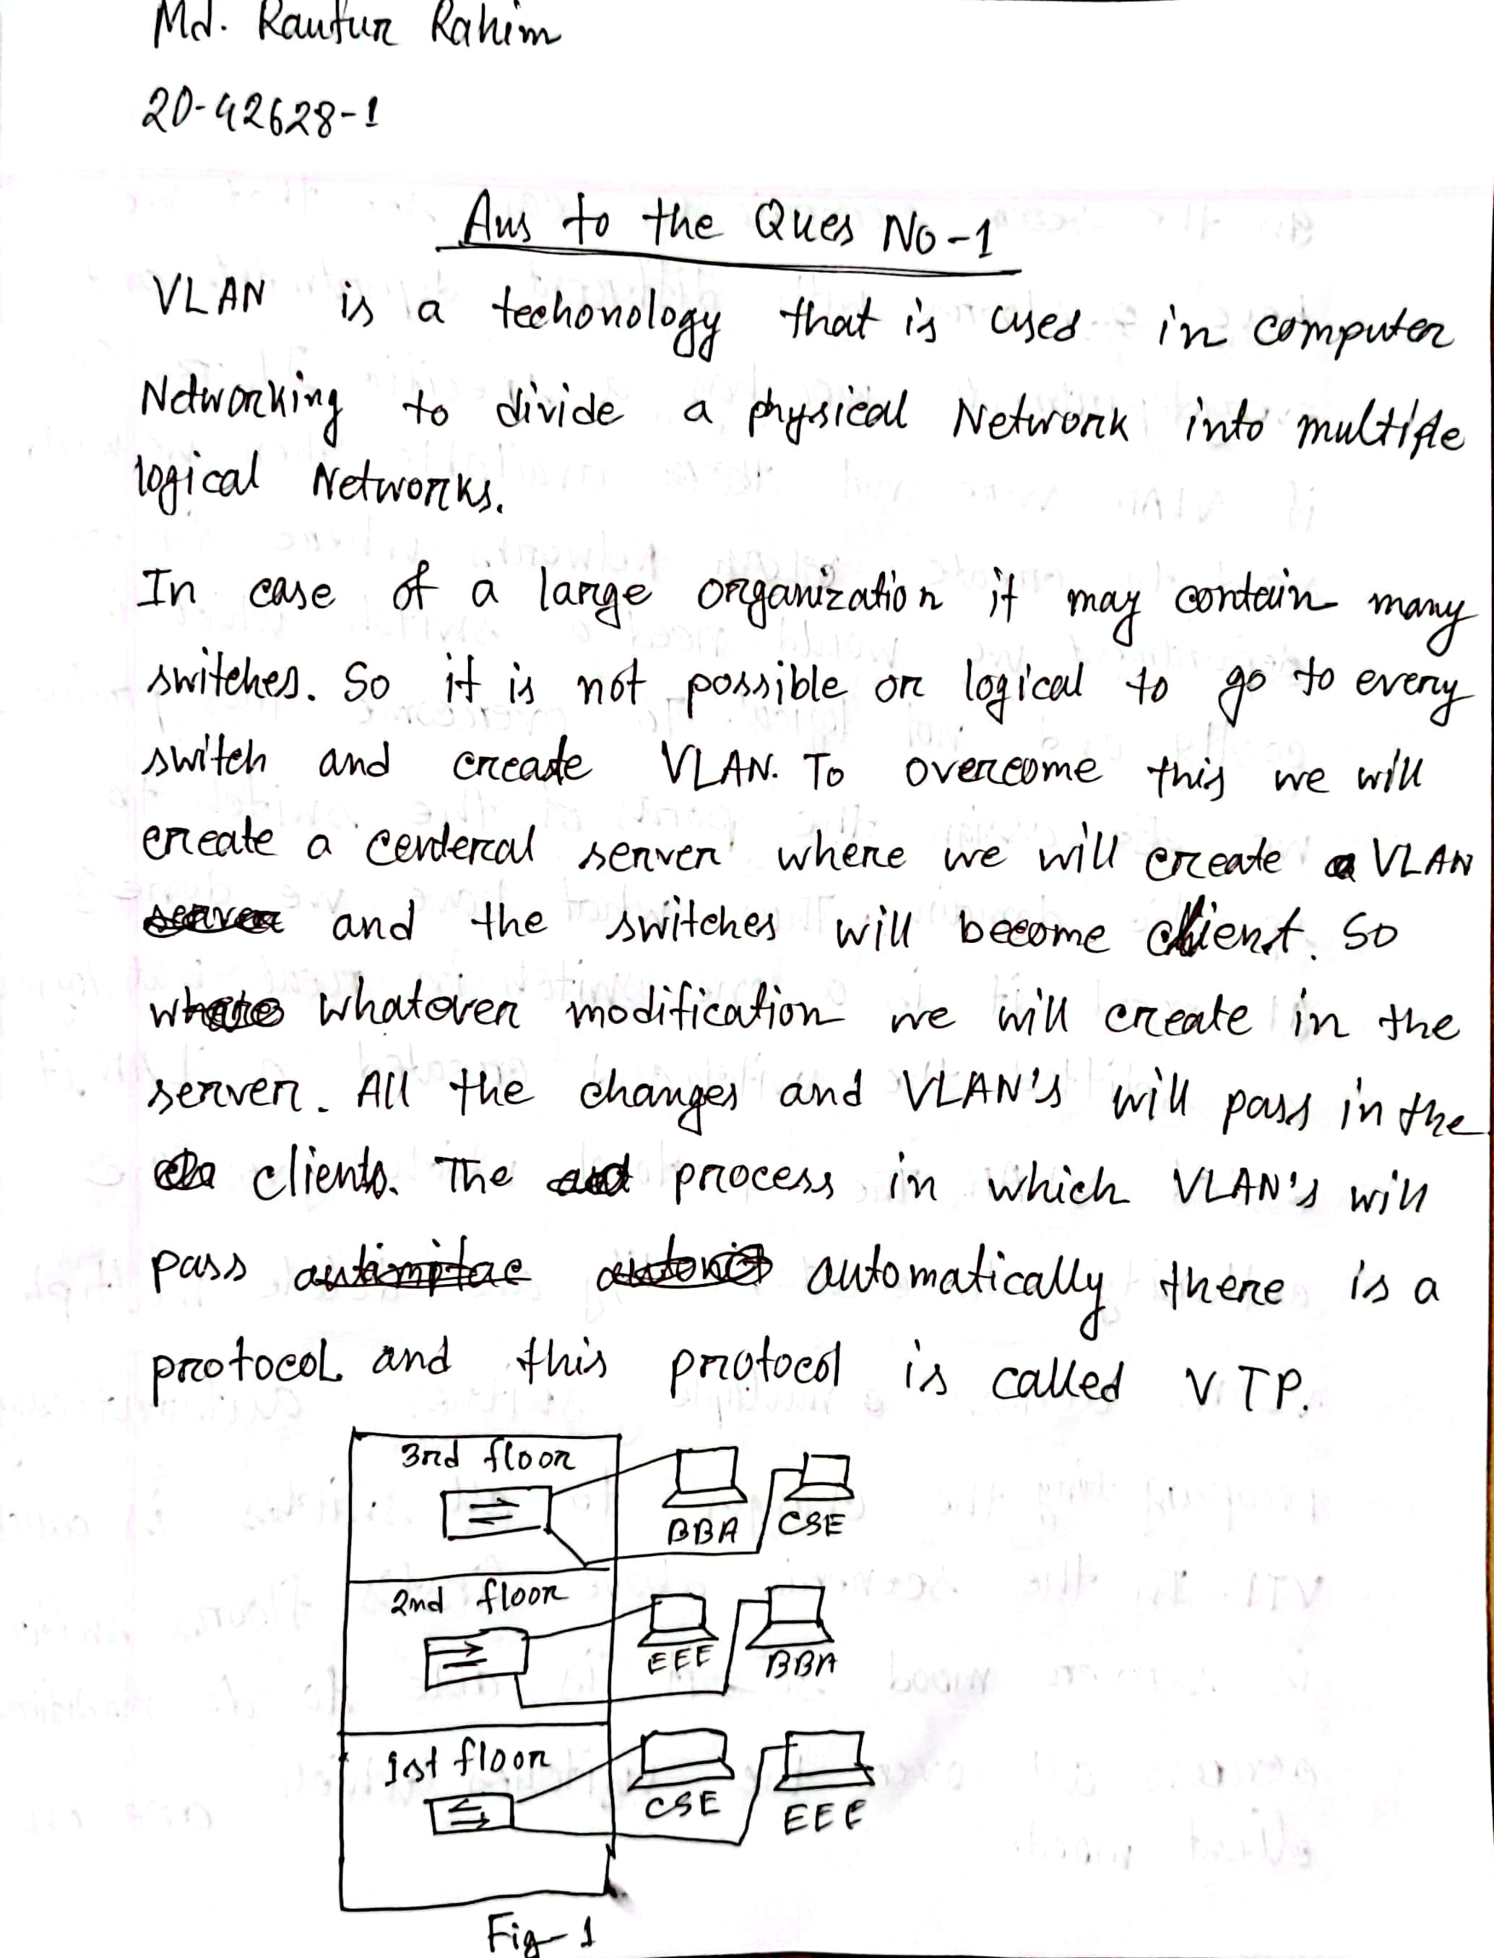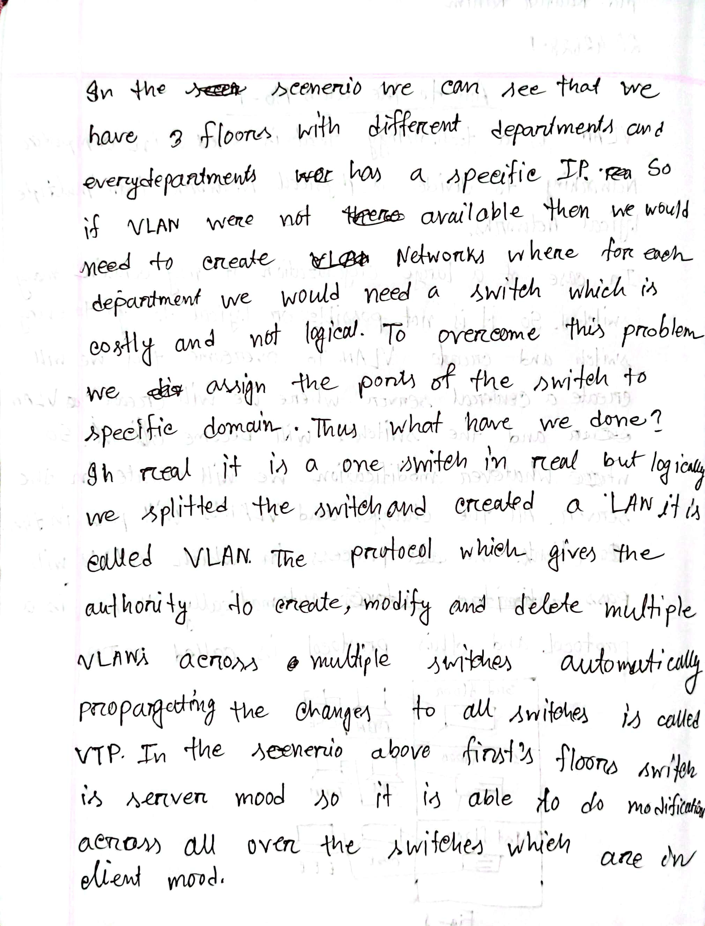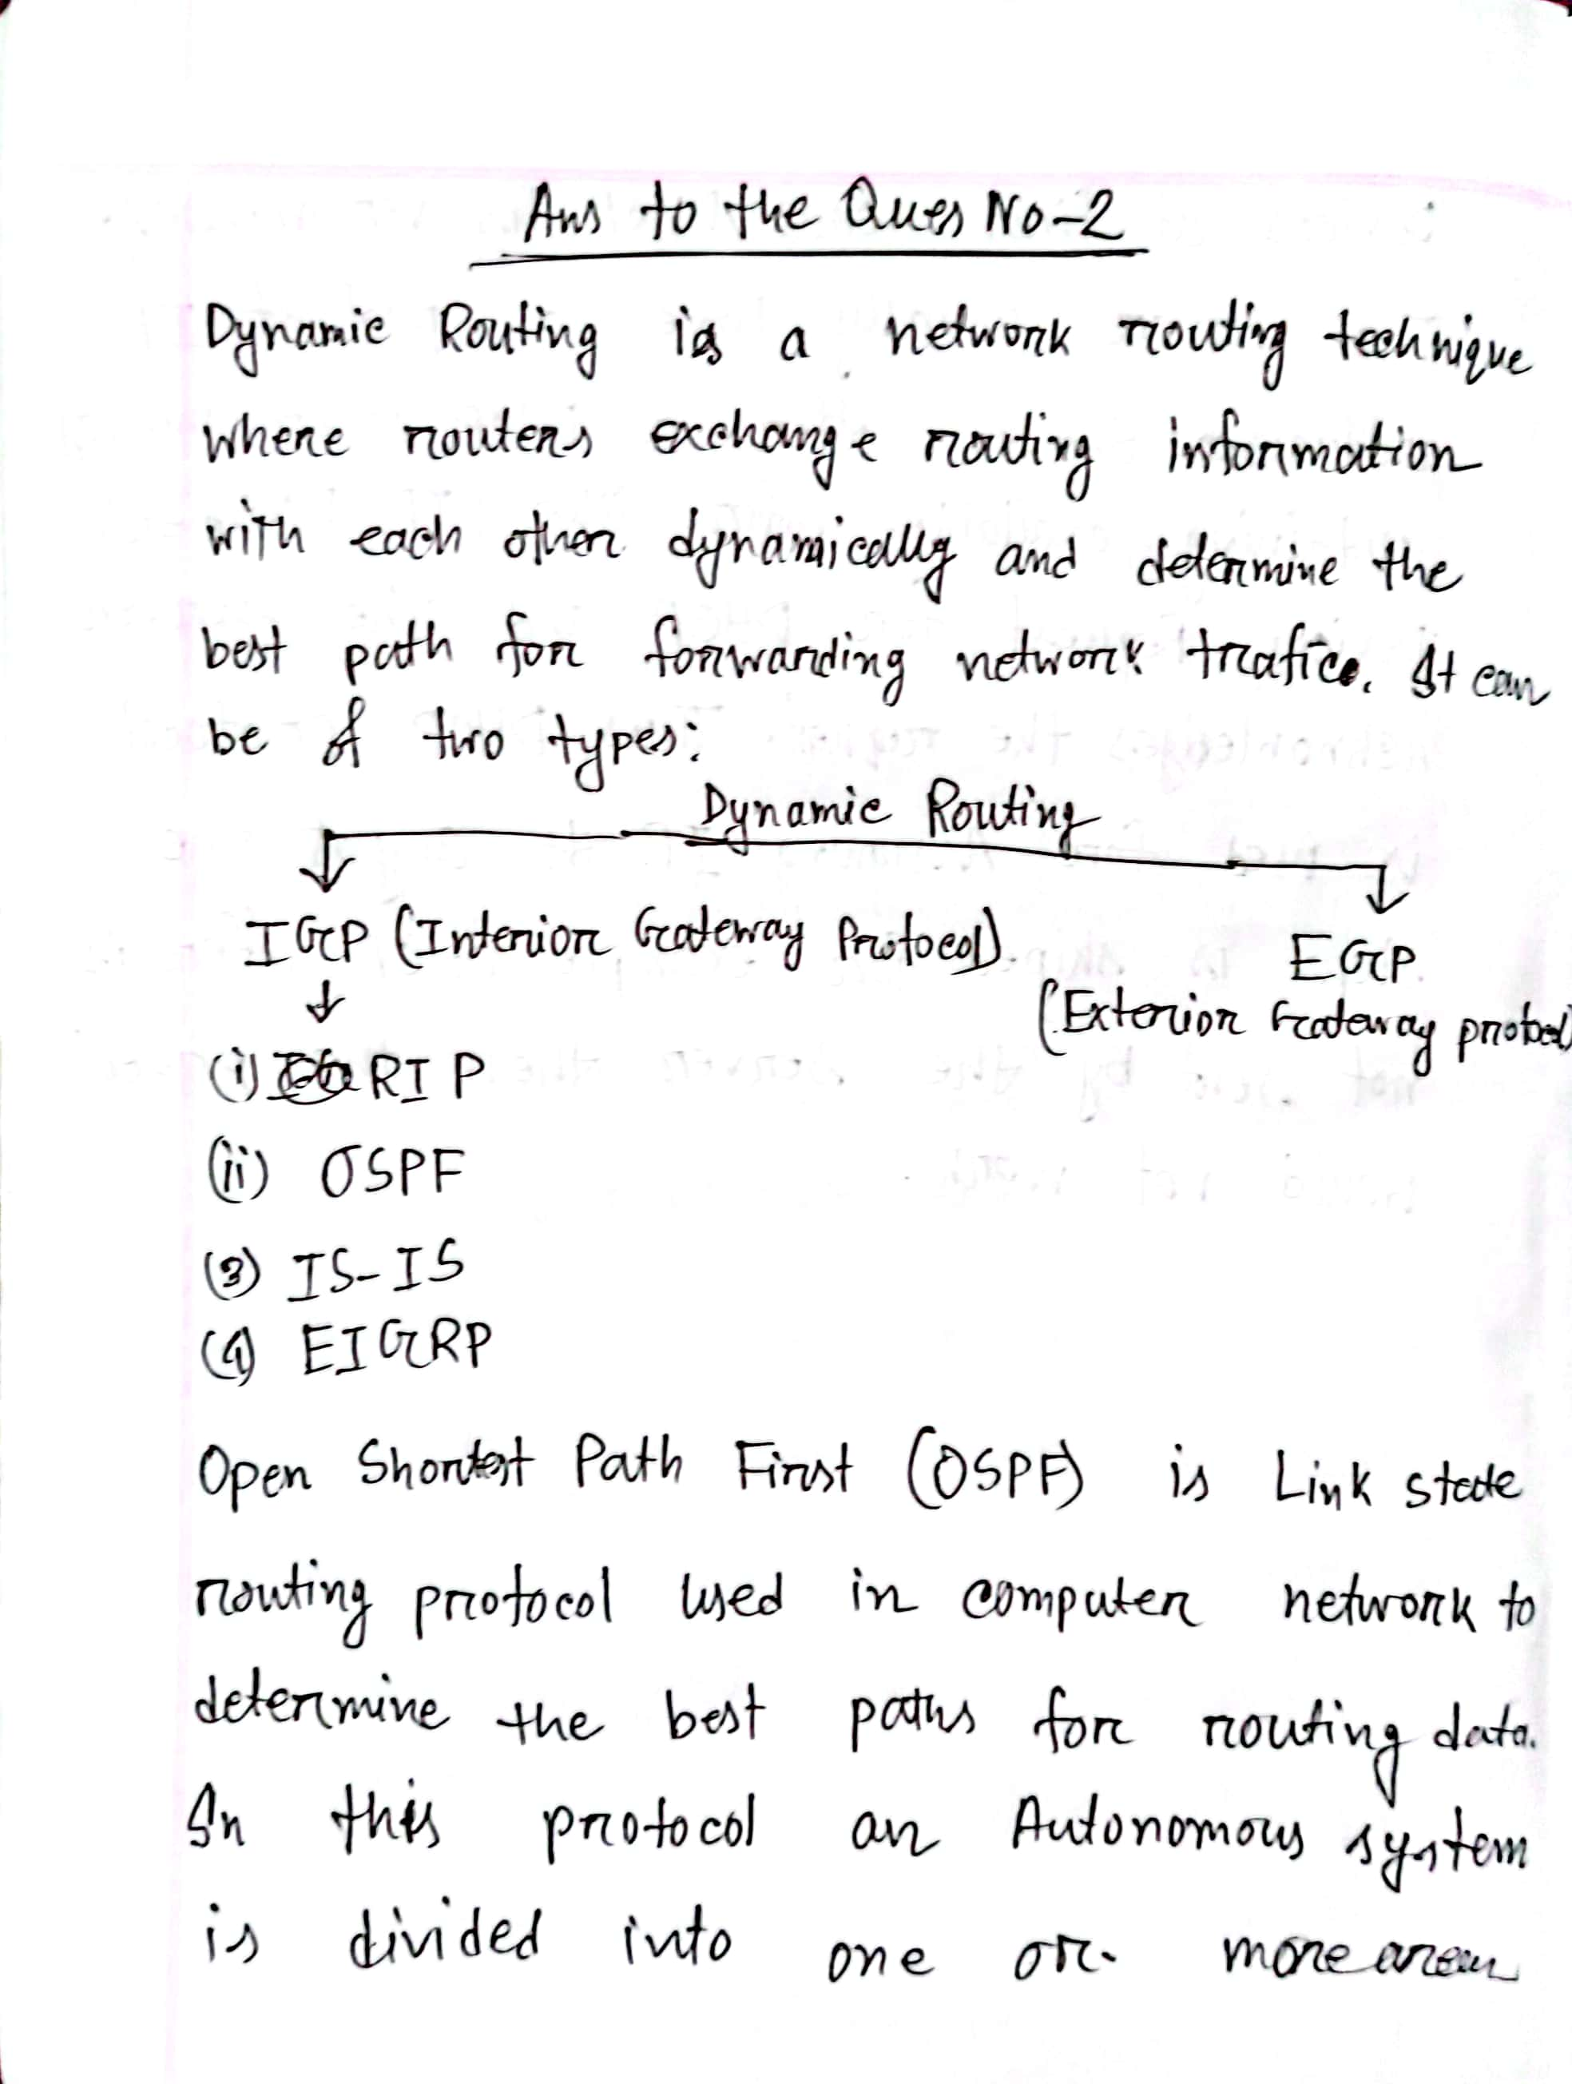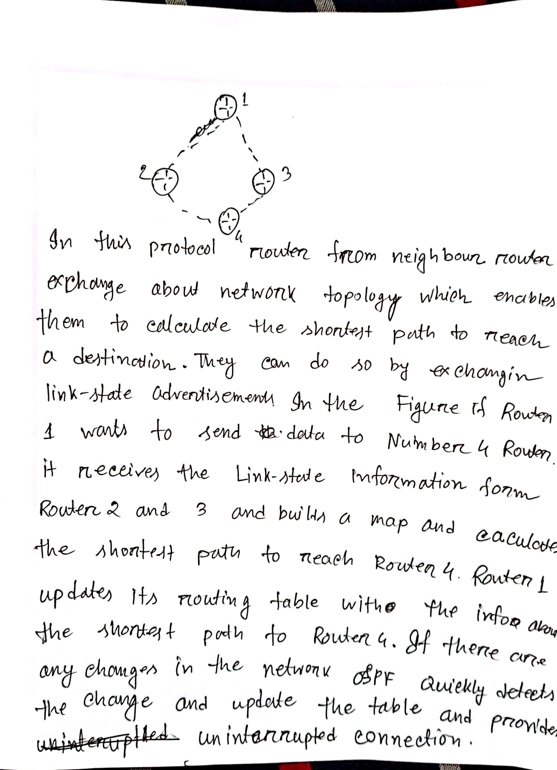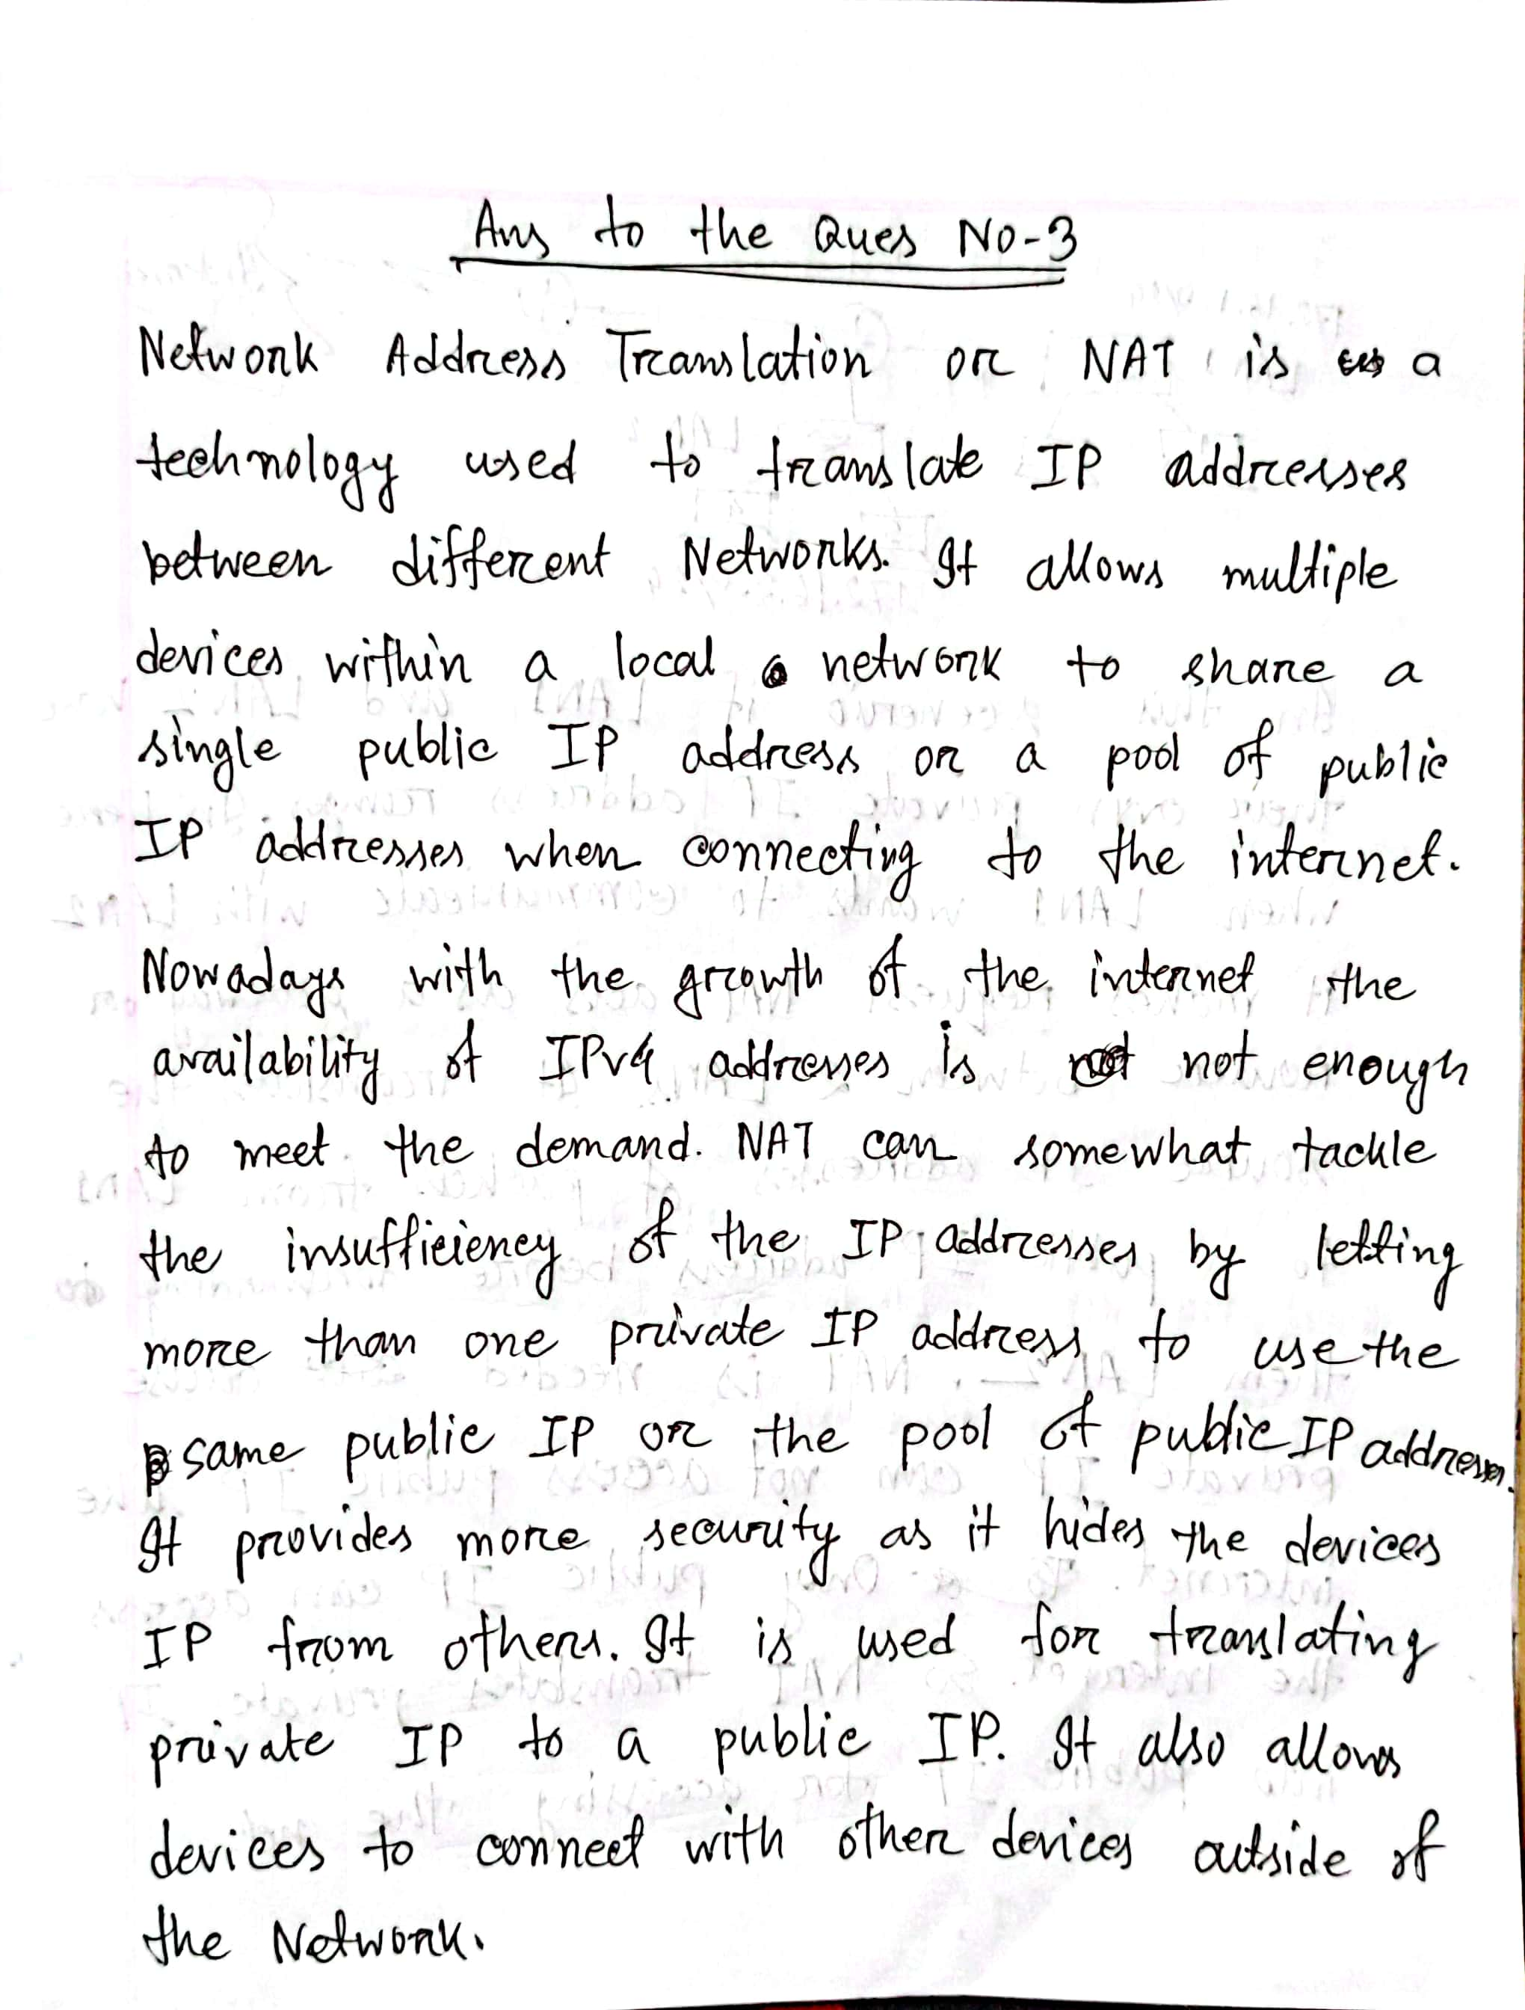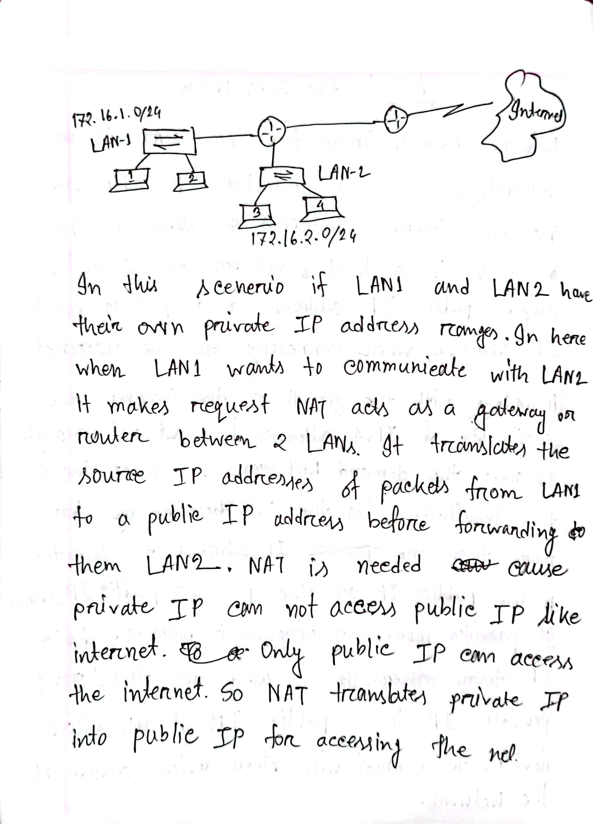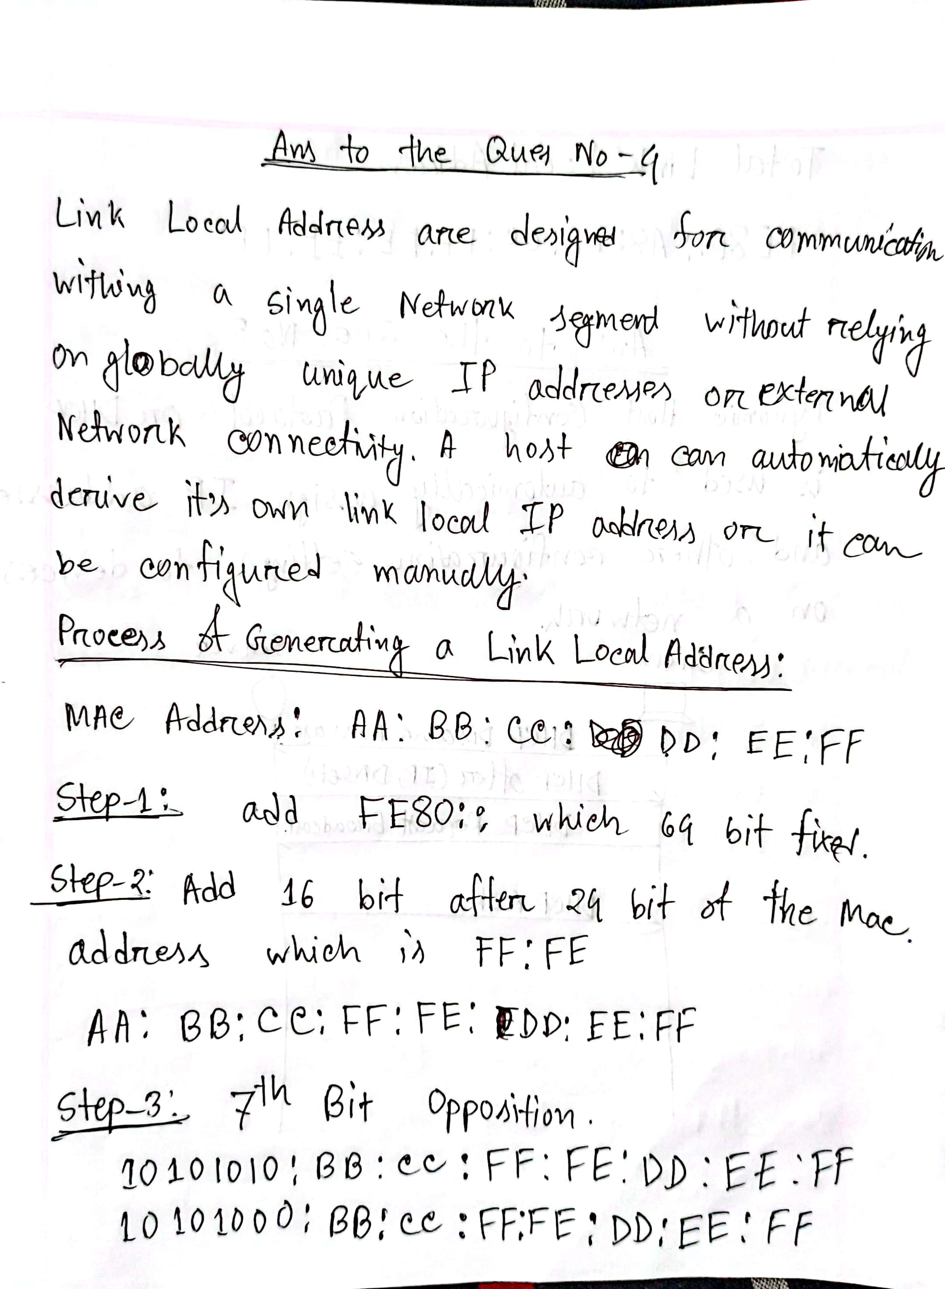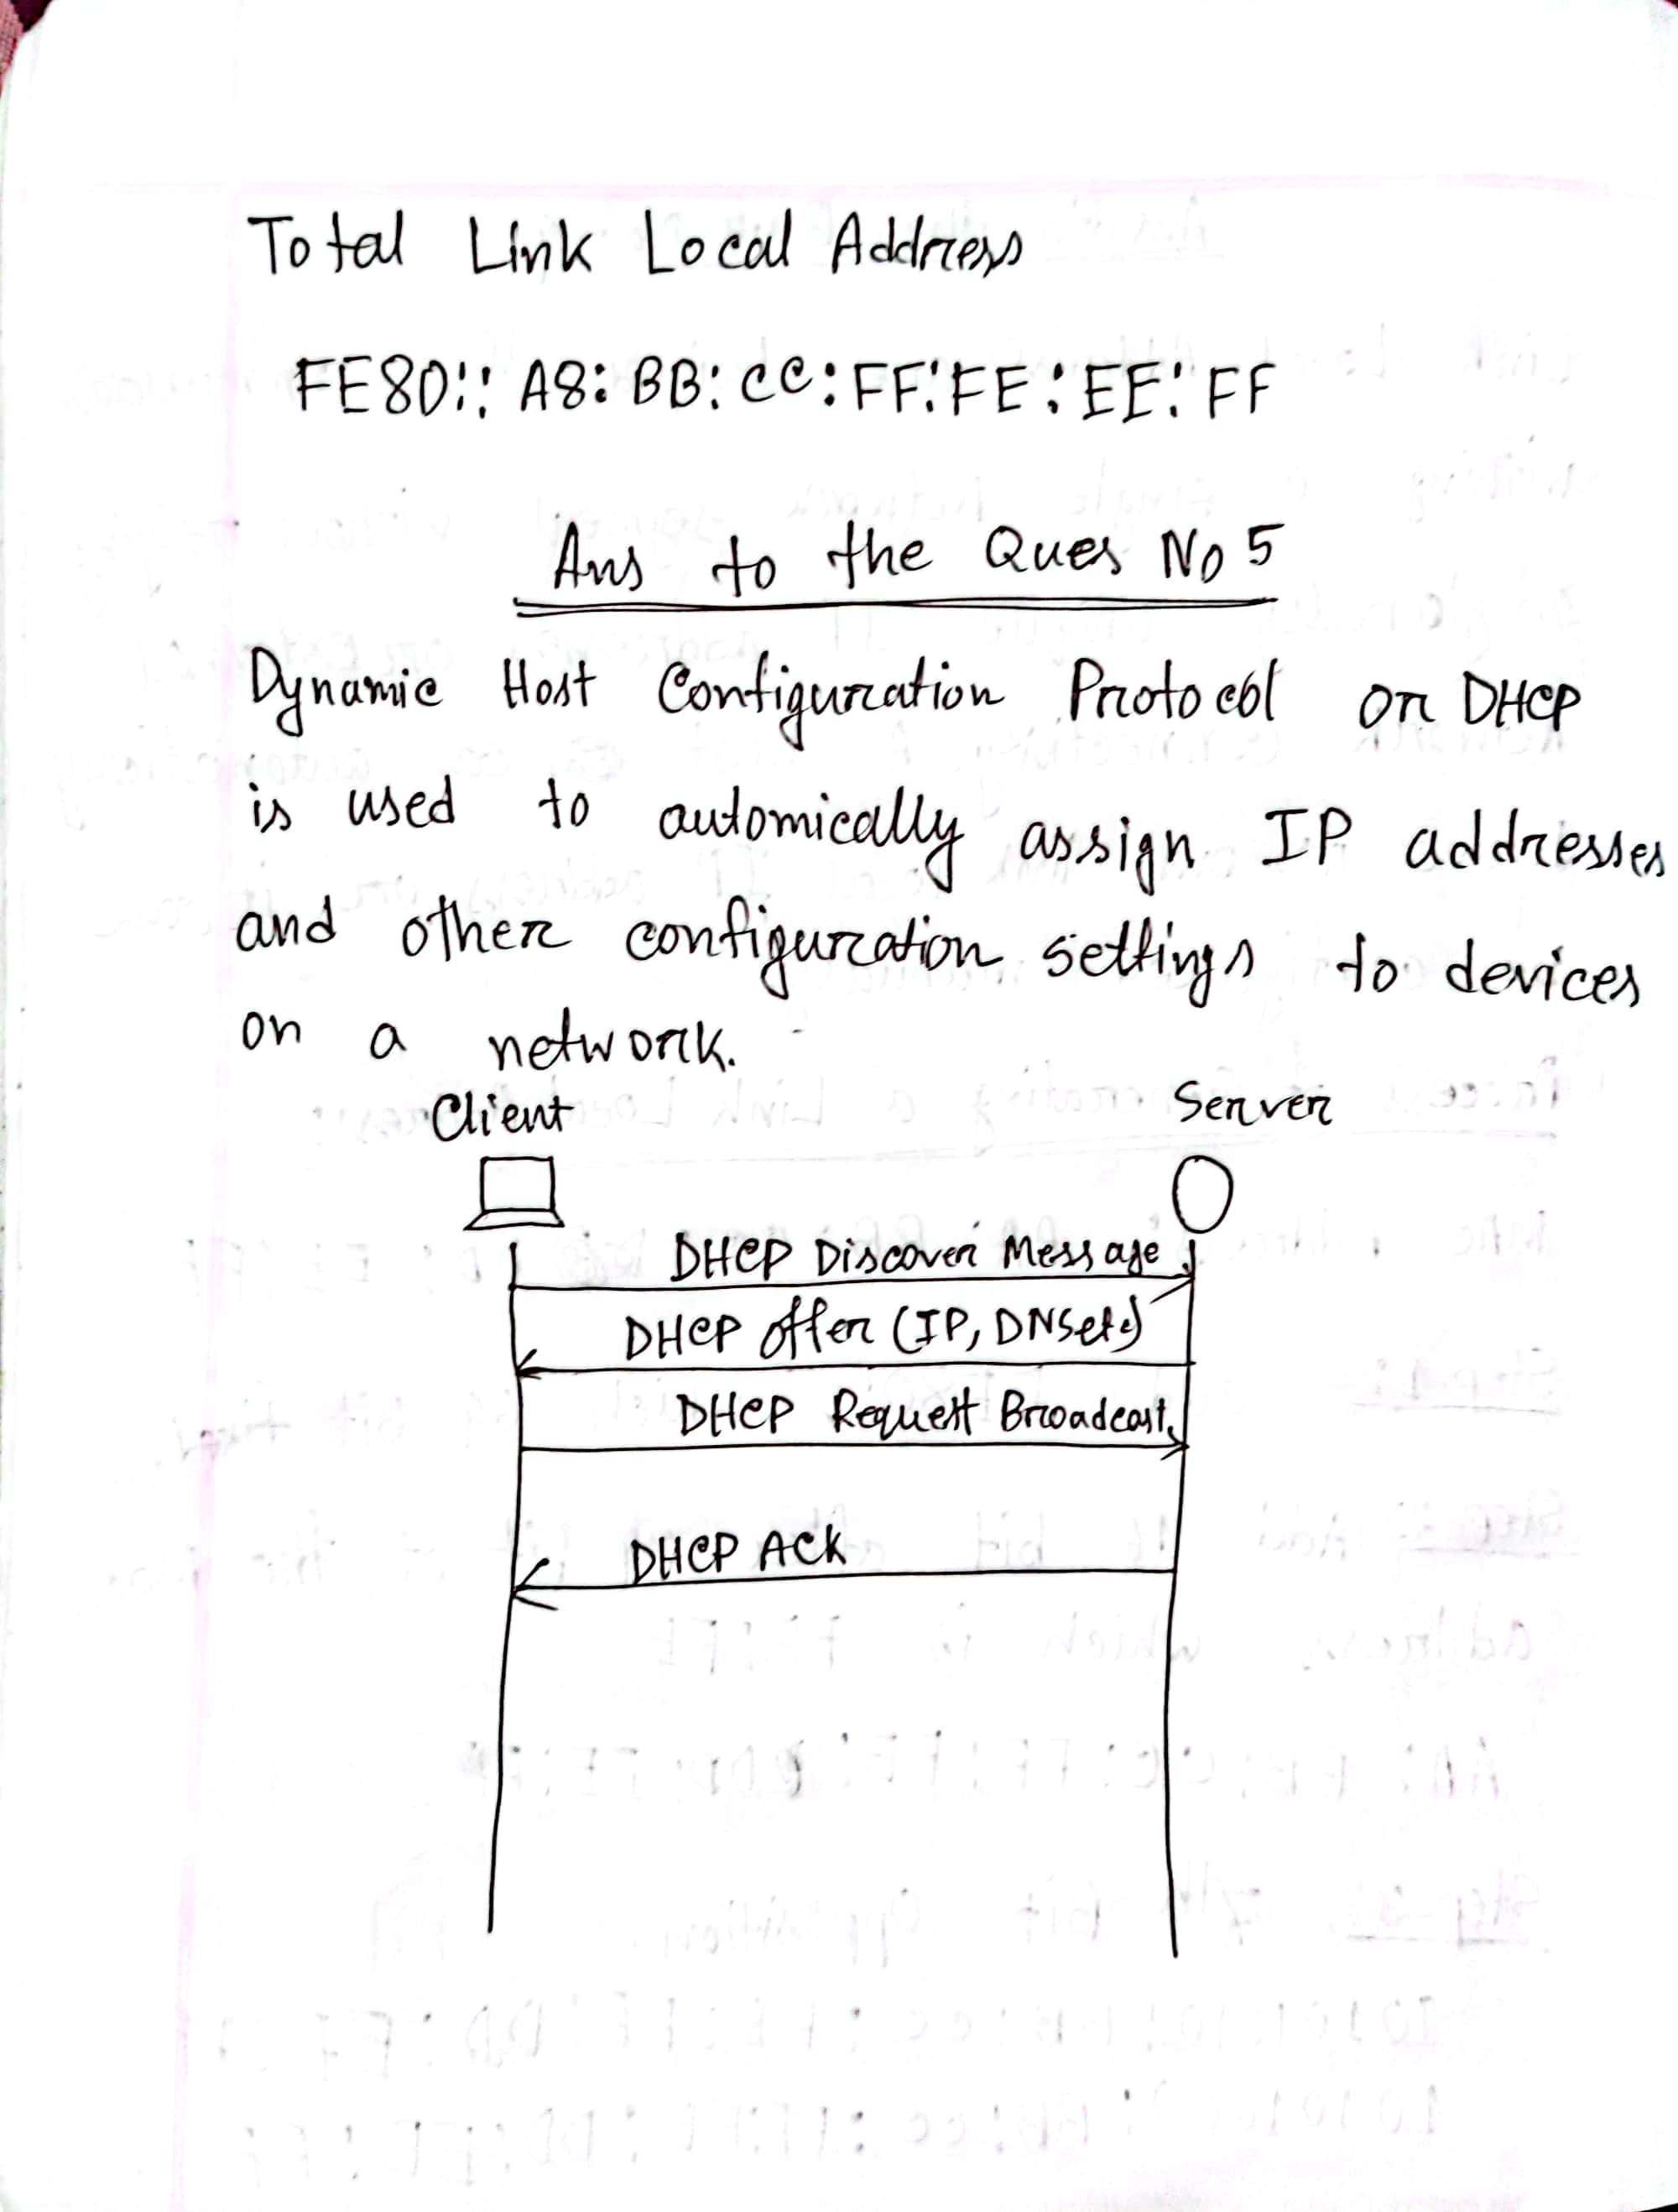

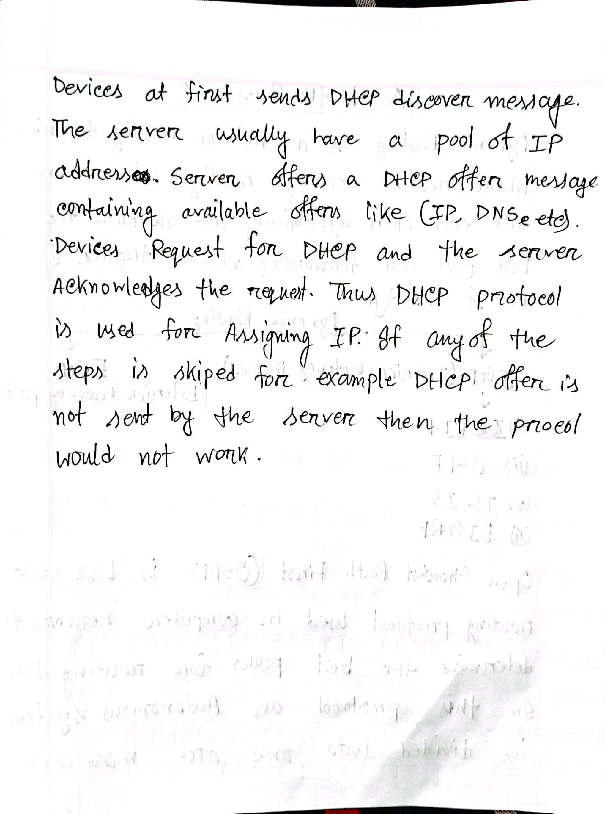

Tue May 23 21:42:34 2023 Switch1 Switch>config t

Tue May 23 21:42:43 2023 Switch1 Switch>enable

Tue May 23 21:43:15 2023 Switch1 Switch#config t

Tue May 23 21:47:04 2023 Switch1 Switch(config)#interface fa0/1

Tue May 23 21:47:10 2023 Switch1 Switch(config-if)#switchport mode trunk

Tue May 23 21:47:15 2023 Switch1 Switch(config-if)#no shut

Tue May 23 21:50:07 2023 Switch1 Switch(config-if)#exit

Tue May 23 21:50:07 2023 Switch1 Switch(config)#interface FastEthernet0/1

Tue May 23 21:52:48 2023 Switch1 Switch(config-if)#interface fa0/2

Tue May 23 21:52:56 2023 Switch1 Switch(config-if)#switchport mode access

Tue May 23 21:53:22 2023 Switch1 Switch(config-if)#interface fa0/3

Tue May 23 21:53:25 2023 Switch1 Switch(config-if)#switchport mode access

Tue May 23 21:57:50 2023 Switch0 Switch>en

Tue May 23 21:57:58 2023 Switch0 Switch#config t

Tue May 23 21:58:13 2023 Switch0 Switch(config)#interface fa0/1

Tue May 23 21:58:18 2023 Switch0 Switch(config-if)#switchport mode trunk

Tue May 23 21:58:23 2023 Switch0 Switch(config-if)#no shut

Tue May 23 21:58:24 2023 Switch0 Switch(config-if)#exit

Tue May 23 22:00:03 2023 Switch0 Switch(config)#interface fa0/2

Tue May 23 22:00:21 2023 Switch0 Switch(config-if)#switchport mode access

Tue May 23 22:00:26 2023 Switch0 Switch(config-if)#interface fa0/3

Tue May 23 22:00:32 2023 Switch0 Switch(config-if)#switchport mode access

Tue May 23 22:07:31 2023 Switch3 Switch>en

Tue May 23 22:07:35 2023 Switch3 Switch#config t

Tue May 23 22:08:00 2023 Switch3 Switch(config)#interface fa0/1

Tue May 23 22:08:09 2023 Switch3 Switch(config-if)#sw m trunk

Tue May 23 22:08:16 2023 Switch3 Switch(config-if)#interface fa0/2

Tue May 23 22:08:21 2023 Switch3 Switch(config-if)#sw m access

Tue May 23 22:08:23 2023 Switch3 Switch(config-if)#interface fa0/3

Tue May 23 22:08:26 2023 Switch3 Switch(config-if)#sw m access

Tue May 23 22:08:35 2023 Switch2 Switch>en

Tue May 23 22:08:38 2023 Switch2 Switch#config t

Tue May 23 22:08:53 2023 Switch2 Switch(config)#interface fa0/1

Tue May 23 22:08:58 2023 Switch2 Switch(config-if)#sw m trunk

Tue May 23 22:09:01 2023 Switch2 Switch(config-if)#interface fa0/2

Tue May 23 22:09:06 2023 Switch2 Switch(config-if)#sw m access

Tue May 23 22:09:09 2023 Switch2 Switch(config-if)#interface fa0/3

Tue May 23 22:09:11 2023 Switch2 Switch(config-if)#sw m access

Tue May 23 22:15:51 2023 Router0 Router>enable

Tue May 23 22:15:51 2023 Router0 Router#configure terminal

Tue May 23 22:15:51 2023 Router0 Router(config)#interface GigabitEthernet0/0/2

Tue May 23 22:16:14 2023 Router0 Router(config-if)#exit

Tue May 23 22:16:14 2023 Router0 Router(config)#interface GigabitEthernet0/0/0

Tue May 23 22:16:16 2023 Router0 Router(config-if)#exit

Tue May 23 22:16:16 2023 Router0 Router(config)#interface GigabitEthernet0/0/1

Tue May 23 22:17:34 2023 Router0 Router(config-if)#no shutdown

Tue May 23 22:20:27 2023 Router0 Router>en

Tue May 23 22:20:30 2023 Router0 Router#config t

Tue May 23 22:20:47 2023 Router0 Router(config)#se 0/1/0

Tue May 23 22:21:02 2023 Router0 Router(config)#interface se0/1/0

Tue May 23 22:21:24 2023 Router0 Router(config-if)#exit

Tue May 23 22:21:24 2023 Router0 Router(config)#interface Serial0/1/0

Tue May 23 22:27:06 2023 Router0 Router(config-if)#ip address 1.1.1.1 255.0.0.0

Tue May 23 22:27:49 2023 Router0 Router(config-if)#no ip address

Tue May 23 22:27:53 2023 Router0 Router(config-if)#ip address 1.1.1.1 255.0.0.0

Tue May 23 22:28:03 2023 Router0 Router(config-if)#ip address 1.1.1.1 255.255.255.252

Tue May 23 22:28:04 2023 Router0 Router(config-if)#no shutdown

Tue May 23 22:28:18 2023 Router1 Router>enable

Tue May 23 22:28:18 2023 Router1 Router#configure terminal

Tue May 23 22:28:18 2023 Router1 Router(config)#interface Serial0/2/1

Tue May 23 22:28:24 2023 Router1 Router(config-if)#ip address 1.1.1.2 255.0.0.0

Tue May 23 22:28:31 2023 Router1 Router(config-if)#ip address 1.1.1.2 255.255.255.252

Tue May 23 22:28:31 2023 Router1 Router(config-if)#no shutdown

Tue May 23 22:28:48 2023 Router0 Router(config-if)#exit

Tue May 23 22:28:49 2023 Router0 Router(config)#interface GigabitEthernet0/0/0

Tue May 23 22:28:50 2023 Router0 Router(config-if)#exit

Tue May 23 22:28:50 2023 Router0 Router(config)#interface GigabitEthernet0/0/1

Tue May 23 22:28:54 2023 Router0 Router(config-if)#exit

Tue May 23 22:28:54 2023 Router0 Router(config)#interface GigabitEthernet0/0/0

Tue May 23 22:28:55 2023 Router0 Router(config-if)#no shutdown

Tue May 23 22:28:59 2023 Router0 Router(config-if)#exit

Tue May 23 22:28:59 2023 Router0 Router(config)#interface GigabitEthernet0/0/1

Tue May 23 22:29:00 2023 Router0 Router(config-if)#no shutdown

Tue May 23 22:29:05 2023 Router1 Router(config-if)#exit

Tue May 23 22:29:05 2023 Router1 Router(config)#interface GigabitEthernet0/0/0

Tue May 23 22:29:06 2023 Router1 Router(config-if)#no shutdown

Tue May 23 22:29:08 2023 Router1 Router(config-if)#exit

Tue May 23 22:29:08 2023 Router1 Router(config)#interface GigabitEthernet0/0/1

Tue May 23 22:29:10 2023 Router1 Router(config-if)#no shutdown

Tue May 23 22:32:02 2023 Router1 Router(config-if)#interface gig0/0/1

Tue May 23 22:32:47 2023 Router1 Router(config-if)#ip add 10.10.40.254 255.255.255.0

Tue May 23 22:32:58 2023 Router1 Router(config-if)#interface gig0/0/0

Tue May 23 22:33:31 2023 Router1 Router(config-if)#ip add 10.10.30.254 255.255.255.0

Tue May 23 22:34:16 2023 Router0 Router(config-if)#interface gig0/0/0

Tue May 23 22:34:55 2023 Router0 Router(config-if)#ip add 10.10.10.254 255.255.255.0

Tue May 23 22:35:13 2023 Router0 Router(config-if)#interface gig0/0/1

Tue May 23 22:35:24 2023 Router0 Router(config-if)#ip add 10.10.20.254 255.255.255.0

Tue May 23 22:36:51 2023 Switch0 Switch>en

Tue May 23 22:36:54 2023 Switch0 Switch#config t

Tue May 23 22:37:04 2023 Switch0 Switch(config)#vtp mode server

Tue May 23 22:37:17 2023 Switch0 Switch(config)#vtp domain google.com

Tue May 23 22:37:35 2023 Switch0 Switch(config)#vtp password cisco

Tue May 23 22:37:47 2023 Switch1 Switch>en

Tue May 23 22:37:49 2023 Switch1 Switch#config t

Tue May 23 22:37:54 2023 Switch1 Switch(config)#vtp mood client

Tue May 23 22:38:03 2023 Switch1 Switch(config)#vtp mode client

Tue May 23 22:38:09 2023 Switch1 Switch(config)#vtp server google.com

Tue May 23 22:38:30 2023 Switch1 Switch(config)#vtp domain google.com

Tue May 23 22:38:40 2023 Switch1 Switch(config)#vtp password cisco

Tue May 23 22:38:51 2023 Switch3 Switch>en

Tue May 23 22:38:53 2023 Switch3 Switch#config t

Tue May 23 22:39:02 2023 Switch3 Switch(config)#vtp mode server

Tue May 23 22:39:10 2023 Switch3 Switch(config)#vtp domain aiub.edu

Tue May 23 22:39:18 2023 Switch3 Switch(config)#vtp password aiub

Tue May 23 22:39:26 2023 Switch2 Switch>en

Tue May 23 22:39:30 2023 Switch2 Switch#config t

Tue May 23 22:39:37 2023 Switch2 Switch(config)#vtp mode client

Tue May 23 22:39:41 2023 Switch2 Switch(config)#vtp domain

Tue May 23 22:39:55 2023 Switch2 Switch(config)#vtp domain aiub.edu

Tue May 23 22:40:07 2023 Switch2 Switch(config)#vtp password aiub

Tue May 23 22:43:47 2023 Router0 Router(config-if)#router eigrp

Tue May 23 22:44:03 2023 Router0 Router(config-if)#router eigrp ?

Tue May 23 22:44:18 2023 Router0 Router(config-if)#router eigrp ?

Tue May 23 22:44:22 2023 Router0 Router(config-if)#router eigrp ?

Tue May 23 22:44:24 2023 Router0 Router(config-if)#router eigrp exit

Tue May 23 22:44:26 2023 Router0 Router(config-if)#exit

Tue May 23 22:44:29 2023 Router0 Router(config)#exit

Tue May 23 22:44:32 2023 Router0 Router#en

Tue May 23 22:44:35 2023 Router0 Router#config t

Tue May 23 22:44:41 2023 Router0 Router(config)#router eigrp ?

Tue May 23 22:44:50 2023 Router0 Router(config)#eigrp 100

Tue May 23 22:45:08 2023 Router0 Router(config)#router eigrp 100

Tue May 23 22:45:39 2023 Router0 Router(config-router)#do show ip route con

Tue May 23 22:47:13 2023 Router0 Router(config-router)#netword 1.1.1.0 0.0.0.255

Tue May 23 22:47:20 2023 Router0 Router(config-router)#network 1.1.1.0 0.0.0.255

Tue May 23 22:48:11 2023 Router0 Router(config-router)#network 10.10.10.0 0.0.0.255

Tue May 23 22:48:17 2023 Router0 Router(config-router)#network 1.1.1.0 0.0.0.3

Tue May 23 22:48:33 2023 Router0 Router(config-router)#network 10.10.20.0 0.0.0.255

Tue May 23 22:48:42 2023 Router1 Router>en

Tue May 23 22:48:45 2023 Router1 Router#config t

Tue May 23 22:49:09 2023 Router1 Router(config)#router eigrp 100

Tue May 23 22:49:16 2023 Router1 Router(config-router)#do show ip route con

Tue May 23 22:49:51 2023 Router1 Router(config-router)#network 1.1.1.0 0.0.0.255

Tue May 23 22:50:33 2023 Router1 Router(config-router)#network 1.1.1.0 0.0.0.3

Tue May 23 22:50:51 2023 Router1 Router(config-router)#network 10.10.30.0 0.0.0.255

Tue May 23 22:50:59 2023 Router1 Router(config-router)#network 10.10.40.0 0.0.0.255